SEO Metadata
- Focus Keyword: best brand design company in Bangalore
- Meta Title: Best Brand Design Company in Bangalore (2026 Guide) | Brewing Ideaz
- Meta Description: Looking for the best brand design company in Bangalore? Learn what to evaluate — portfolio, process, pricing & red flags — before you hire.
- URL Slug: /best-brand-design-company-in-bangalore

Secondary Keywords
- brand design company in Bangalore
- branding agency in Bangalore
- brand identity design Bangalore
- branding services in Bangalore
- creative design agency Bangalore
- logo design company Bangalore
- professional branding company Bangalore
- brand strategy agency Bangalore
- visual identity design Bangalore
- Brewing Ideaz Bangalore

Internal Linking Suggestions
- /services/ or /brand-design/
- /contact-us/
- /portfolio/ or /case-studies/

Best Brand Design Company in Bangalore: A Complete Guide to Choosing the Right Partner
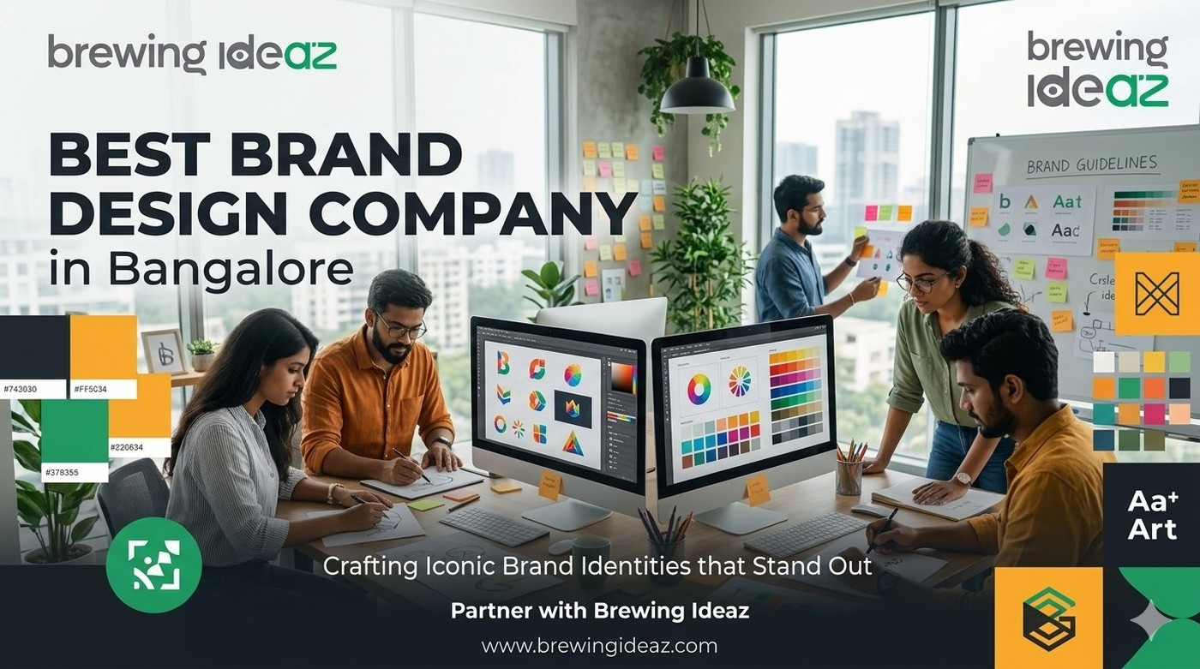
Bangalore is home to thousands of startups, SaaS companies, and D2C brands — which also means hundreds of agencies claim to be the “best brand design company in Bangalore.” For founders and marketing leads, that makes choosing the right partner confusing. A quick Google search rarely reveals who actually delivers strong, strategic brand identities versus who only has a polished website.
This guide gives you a clear framework to evaluate brand design partners in Bangalore so you can make a confident decision.

What “Best” Actually Means in Brand Design
Brand design is more than a logo. A capable agency should help define your brand strategy (positioning, tone of voice, target audience), translate it into a complete visual identity system (logo, colour palette, typography, iconography), and provide guidelines that keep your brand consistent across website, packaging, social media, pitch decks and more.
The right company depends on fit. A studio strong in luxury retail may not be ideal for a fintech startup, and vice versa.

Key Factors to Evaluate Before Hiring

Portfolio depth, not just polish
Ask to see full brand systems applied across multiple touchpoints, ideally with results.

Strategic process
Strong agencies begin with research and positioning before design. Jumping straight to logo concepts is a red flag.

Industry experience
Brand design for a Bangalore tech startup differs from hospitality or FMCG. Ask for relevant examples.

Transparent pricing and timelines
Expect clear fee structures and realistic timelines (typically 3–8 weeks for a full identity).

Ownership of files
Confirm you receive complete source files (AI, EPS, brand guidelines PDF) and full ownership.

Communication style
Check whether their working rhythm (calls, Slack, async updates) matches your team.

Why a Bangalore-Based Brand Design Agency Has an Edge
Working with a local partner offers overlapping working hours, familiarity with Bangalore’s startup and investor ecosystem, and a better understanding of the city’s diverse audience — from tech professionals to traditional businesses. Many Bangalore agencies also have experience creating brand identities that work well in fundraising conversations with VCs.

Questions to Ask Before You Hire
- Can you walk me through your brand strategy process step by step?
- Do you have case studies in my industry or a similar growth stage?
- What exactly is included in the final deliverable package?
- How many rounds of revisions are included?
- Who will actually work on my project — senior designer or junior team?

Red Flags to Watch For
Be cautious of agencies that promise a complete brand identity in 2–3 days, refuse to share client references, or price significantly below market without clear explanation. Branding is a long-term investment; the cheapest option often becomes the most expensive when rework is needed.

Final Thoughts
The best brand design company in Bangalore for your business is the one that understands your audience, follows a clear strategic process, and delivers a scalable system — not just a logo file. Review portfolios carefully, ask the right questions, and prioritise strategic thinking over speed or the lowest price.

Ready to Discuss Your Brand?
Brewing Ideaz is a brand design and digital agency with its corporate office in Bengaluru (Sarjapur – Marathahalli Road) and a branch in Kolkata.
Call or WhatsApp: (+91) 62915 47048 Email: info@brewingideaz.com
We’re happy to share how we approach brand identity projects for growing businesses.

30 Frequently Asked Questions About Brand Design Company in Bangalore
- What is a brand design company? A brand design company helps businesses develop their brand identity, including logos, colours, typography, visual elements, and brand guidelines.
- How do I choose the best brand design company in Bangalore? Evaluate the company’s portfolio, strategic process, relevant industry experience, pricing, deliverables, and communication style.
- What services does a brand design company offer? Services may include brand strategy, logo design, visual identity, brand guidelines, packaging design, and marketing collateral.
- Why is brand identity important for a business? A consistent brand identity helps businesses communicate their values, establish recognition, and create a coherent experience across customer touchpoints.
- What is the difference between branding and brand design? Branding covers the broader process of shaping a brand’s identity and perception. Brand design focuses on the visual elements that express that identity.
- How much does brand design cost in Bangalore? Pricing varies depending on the scope, complexity, deliverables, and experience of the agency. Request a detailed quotation before hiring.
- How long does a complete brand identity project take? A full brand identity project may typically take 3–8 weeks, depending on the scope, feedback cycles, and project requirements.
- What should a brand design portfolio include? A portfolio should demonstrate complete identity systems, design applications, project objectives, and relevant examples of completed work.
- What is brand strategy? Brand strategy defines a brand’s positioning, target audience, values, messaging, and differentiation in the market.
- What is a visual identity system? A visual identity system includes the logo, colour palette, typography, imagery, and other visual elements used to represent a brand consistently.
- What is included in a brand identity package? Depending on the agreement, it may include logo variations, colour specifications, typography, brand guidelines, and digital or print-ready assets.
- Why should I check an agency’s industry experience? Relevant experience can help you assess whether the agency understands your audience, industry requirements, and business objectives.
- What questions should I ask before hiring a branding agency? Ask about the strategy process, relevant projects, deliverables, revision limits, project timeline, pricing, and team members.
- What are the red flags when hiring a brand design company? Unclear deliverables, unrealistic timelines, lack of relevant work, vague pricing, and unclear ownership terms deserve careful evaluation.
- What is the difference between a logo and a brand identity? A logo is one visual element of a brand. A brand identity is the broader system of visual elements and guidelines that represent the business.
- Do startups need professional brand design? Professional brand design can help startups communicate their positioning consistently and establish a recognizable identity as they grow.
- Can a brand design agency help with rebranding? Yes. Agencies may help businesses update their positioning, visual identity, messaging, and brand guidelines during a rebranding project.
- What are brand guidelines? Brand guidelines document how a brand’s visual and communication elements should be used consistently across different platforms.
- Why is brand consistency important? Consistent branding helps customers recognize a business and experience a coherent identity across its website, marketing materials, and other touchpoints.
- What file formats should I receive from a brand design company? Depending on the project, deliverables may include editable vector files such as AI or EPS, SVG assets, PNG files, and a brand guidelines PDF.
- Who owns the final brand design files? Ownership depends on the contract. Confirm the transfer of intellectual property rights, source files, and usage permissions in writing.
- How many revisions should a branding project include? Revision limits vary by agency and project. Confirm the number of included rounds and the cost of additional changes before signing.
- Why choose a Bangalore-based branding agency? A local agency may offer convenient communication, familiarity with the regional market, and opportunities for in-person collaboration.
- What is the difference between a branding agency and a marketing agency? A branding agency focuses on brand identity and positioning, while a marketing agency focuses on promoting products or services and reaching target audiences. Some agencies offer both.
- Can brand design improve customer trust? A clear and consistent brand identity can support credibility and recognition, although trust also depends on the actual customer experience and business practices.
- What is brand positioning? Brand positioning defines how a business wants its target audience to perceive it in relation to competing options.
- How can I compare two brand design companies? Compare their relevant portfolios, strategic approach, deliverables, project timelines, pricing, communication, and contractual terms.
- What is the role of typography in brand design? Typography influences the visual character, readability, and consistency of a brand’s communication.
- Does a brand design company provide ongoing support? Some agencies offer ongoing design support or brand management services. Confirm availability, scope, and pricing directly with the agency.
- How can I contact Brewing Ideaz for brand design services in Bangalore? You can contact Brewing Ideaz by calling or WhatsApping +91 62915 47048 or emailing info@brewingideaz.com to discuss your branding requirements.

